Hardcoding Issues – Part 1

Open the DIVA application



Select the second lab – Hardcoding Issues part 1

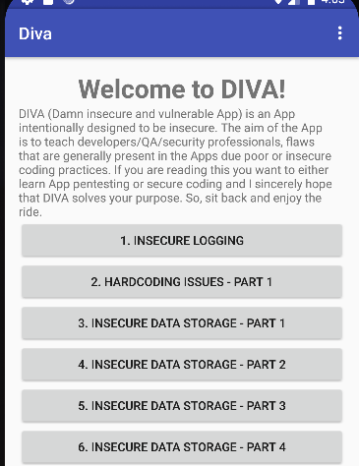

This screen is presented where we have an input field

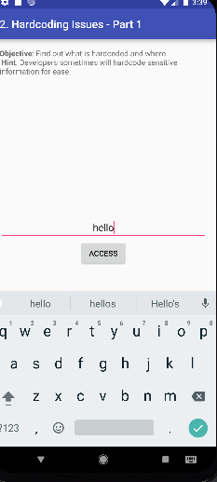

When we write invalid access id, we are given a message:



We will use JADX to analyze the code of this application. When analyzing, we see that that source code contains the valid access ID.

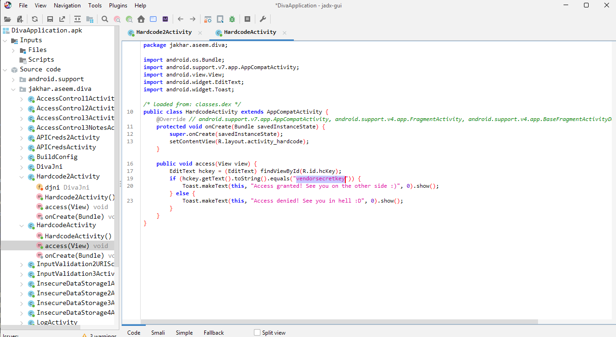

We will input this access Id in the input field.

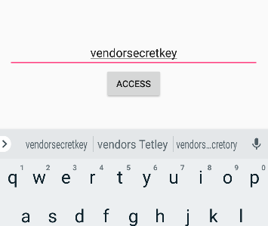

We can notice that the access Id is valid as per the message displayed.

